EL#GY 9333 – Data

Center and Cloud Computing

Lab # 2

- A screenshot of OpenFlow control messages you captured with WireShark.
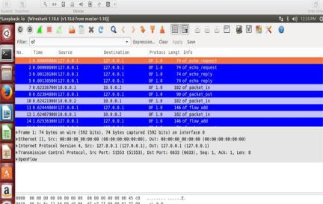

(b) Output of mininet "net" command for both topologies.

The following screenshot shows the "net" command for the 1st topology
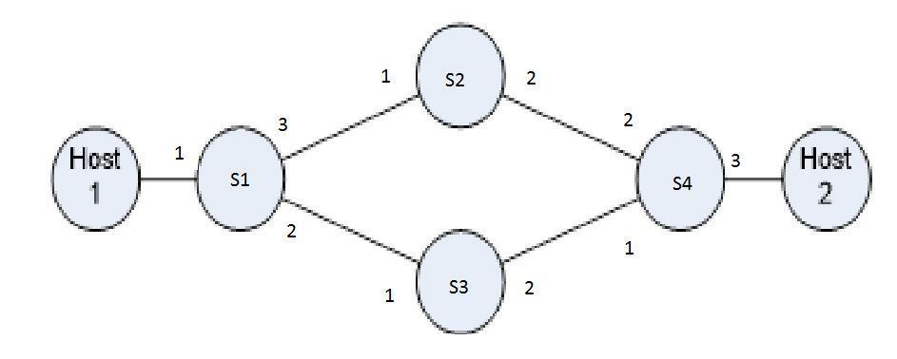
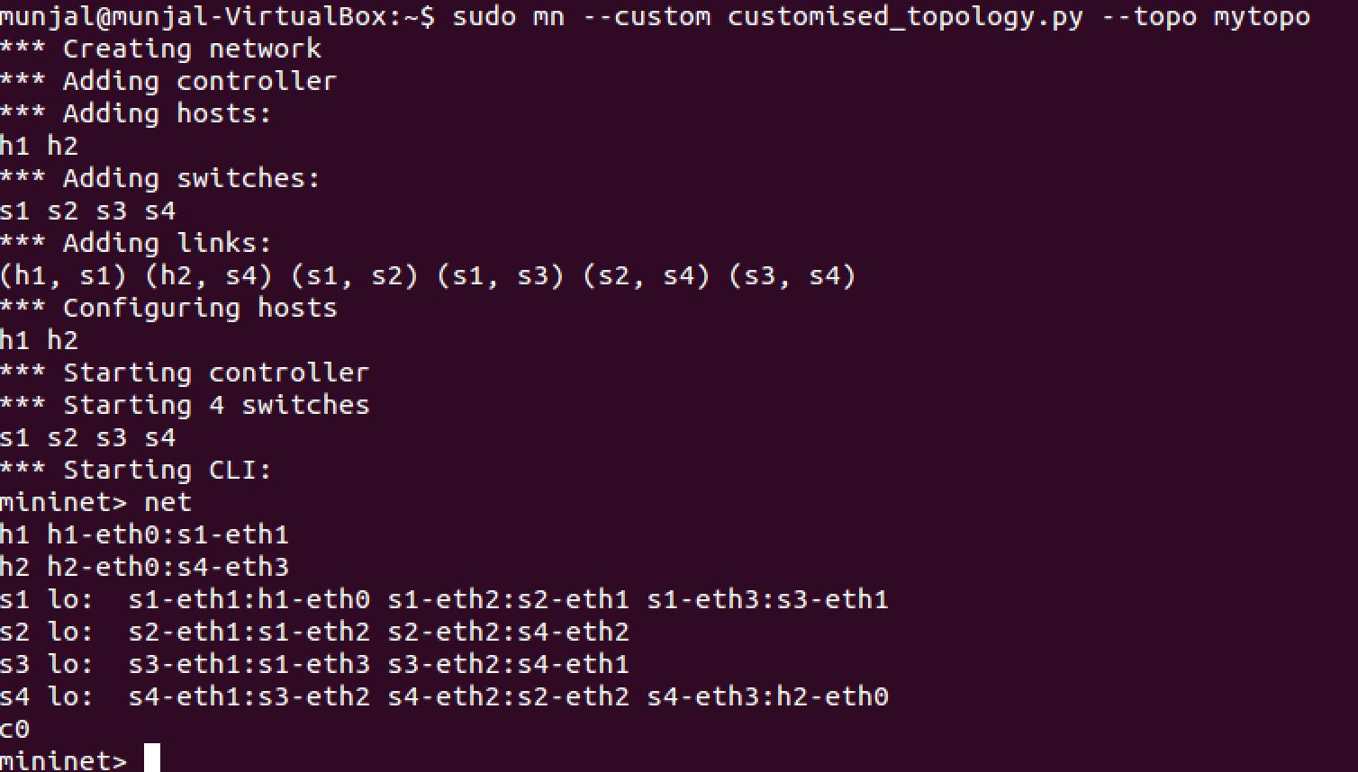

The following screenshot shows the "net" command for the fat tree topology
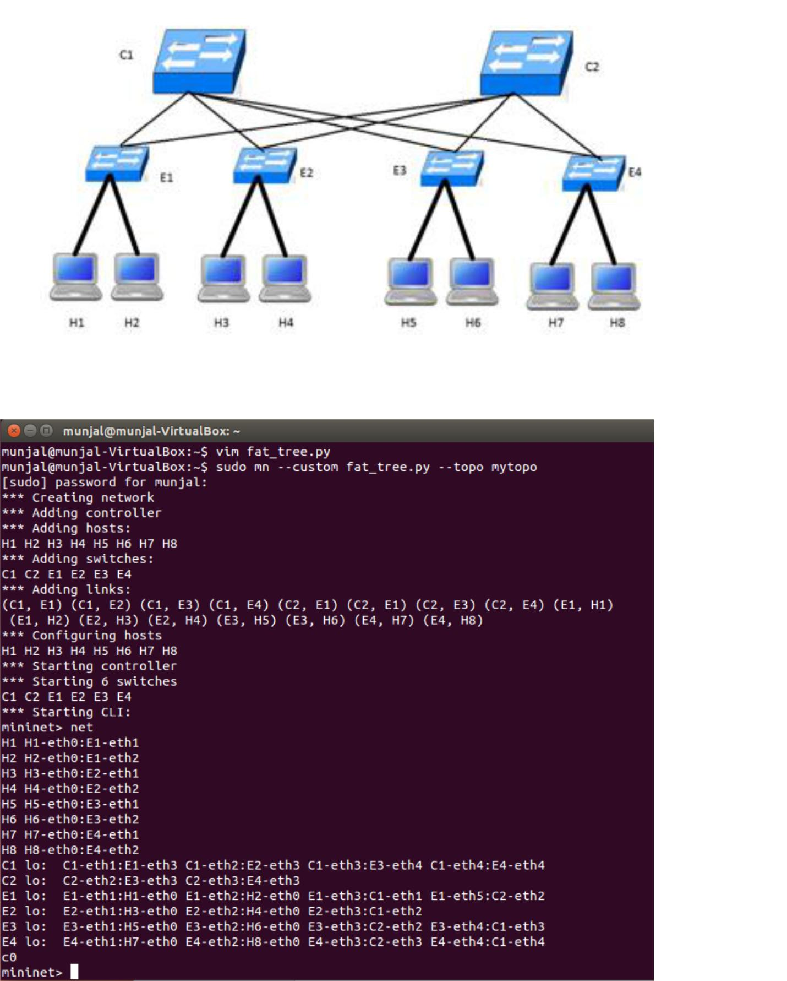
(c) Mininet output while creating the networks and the modified custom topology files (.py files) for both topologies.

NOTE:We are attaching our Python Files we used for creating both topology
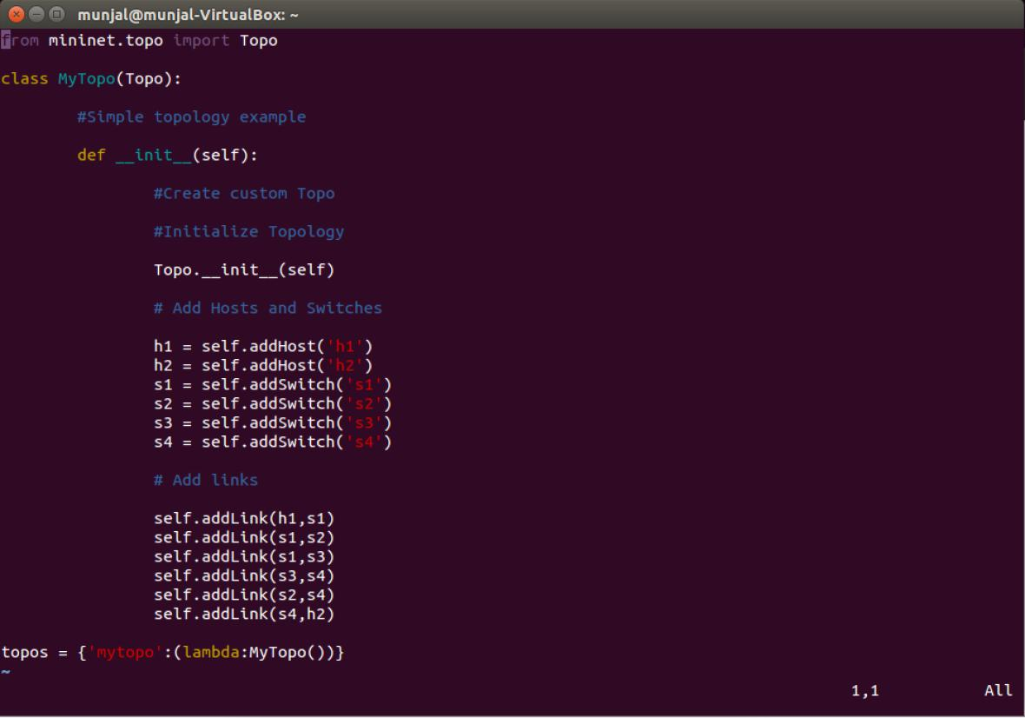
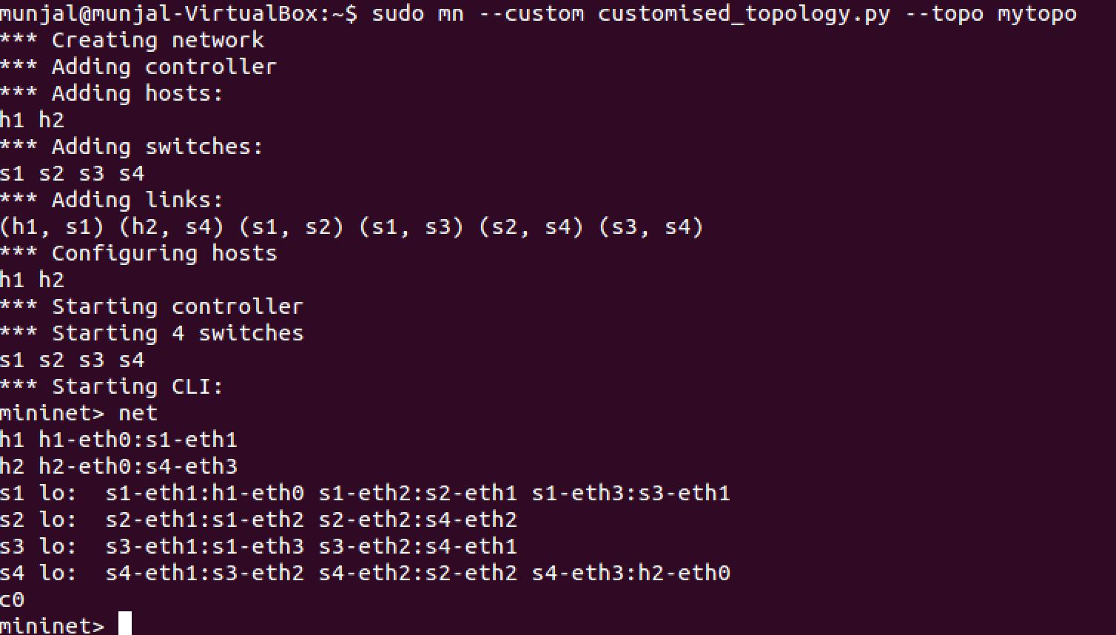
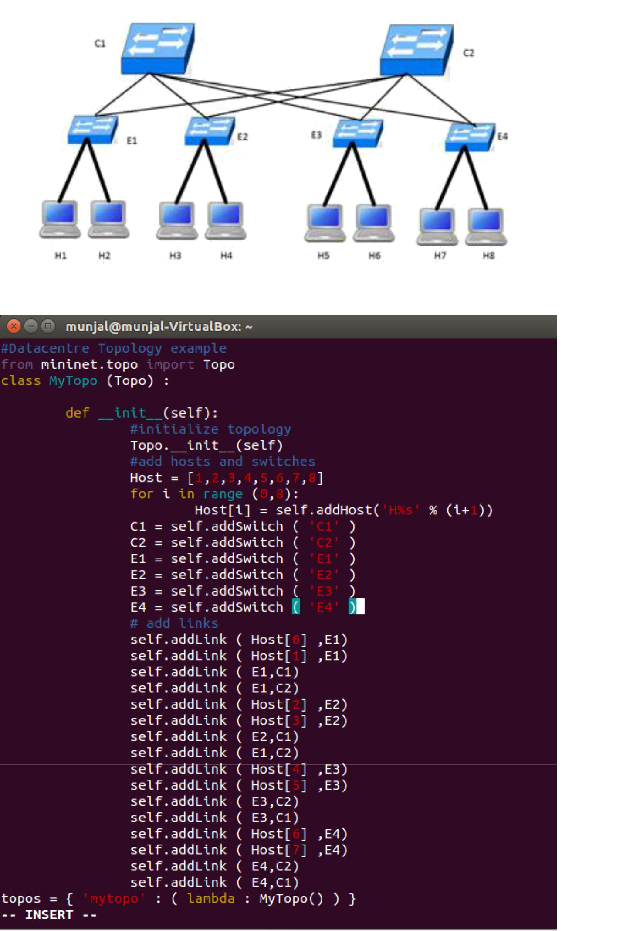
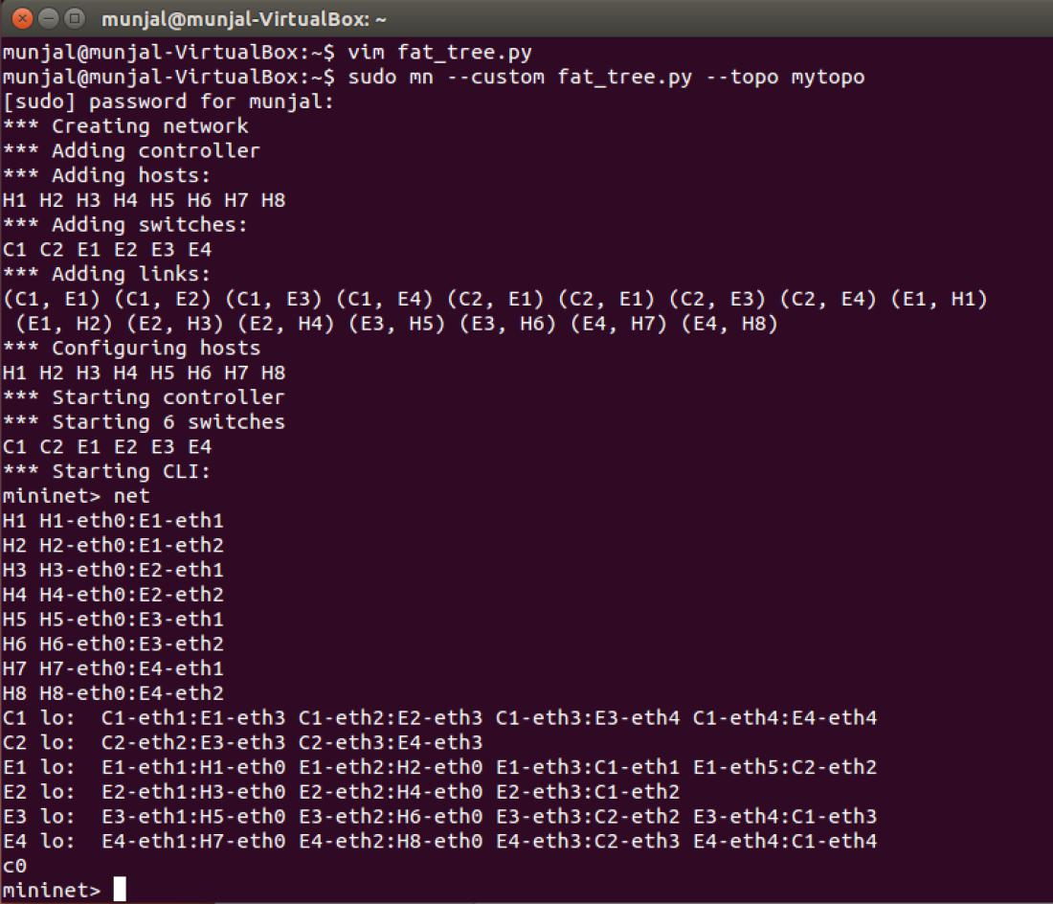
(d) Wireshark screenshots showing the packets on link B-D and link C-D

The following screenshot shows the path taken by a flow from host1 to host2 with TCP destination port 80 is s2-eth2 i.e. link B-D
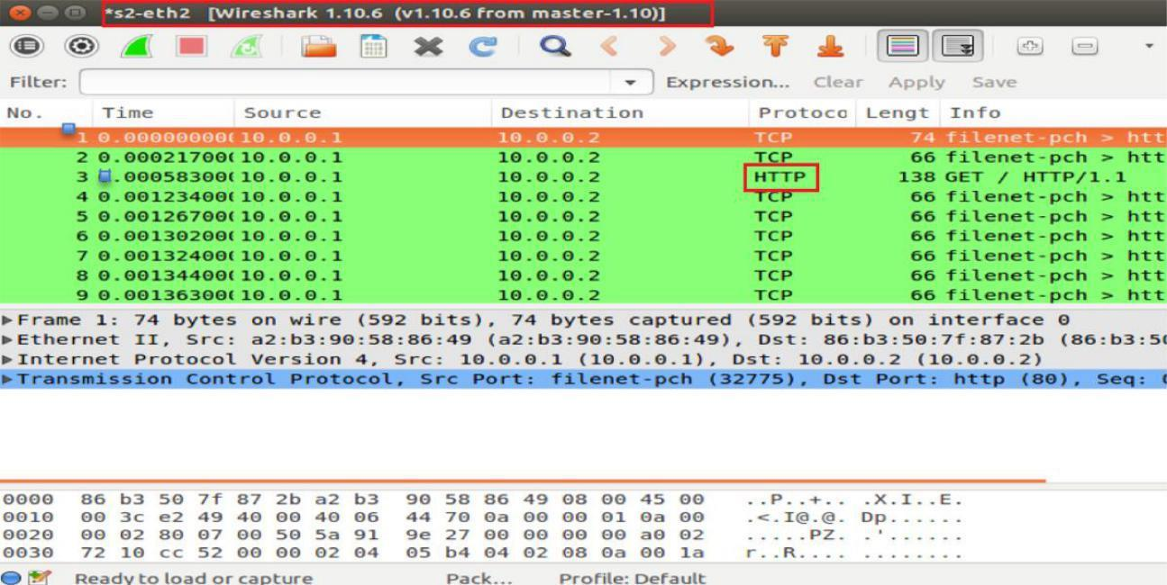

Here, we made host2 a http server and we ran command "h1 curl h2" from host1 which choose the path B-D
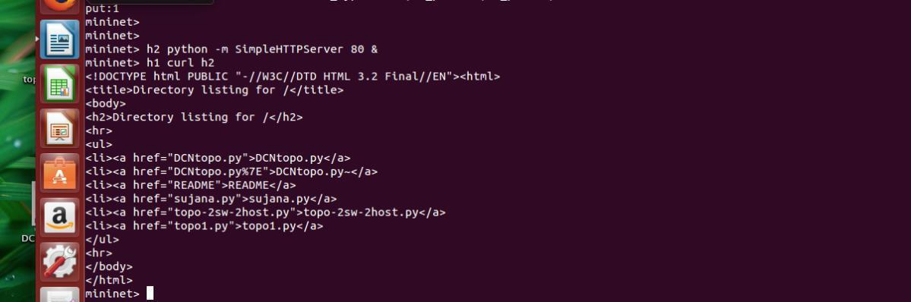

 

 
 

→

The following screenshot shows the path taken by a flow from host1 to host2 with UDP destination port 5353 is s3-eth2 i.e. link C-D
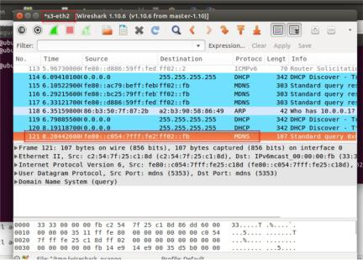

(e) Briefly explain how you produce different traffic to verify whether the rules installed function correctly.

We first produce traffic (shown in wireshark in Question D -1st wireshark) with source as host1 and destination as host 2 with destination port 80 by using iperf command as:

Iperf –c 10.0.0.2 –p 80 in command window of Host 2

Iperf –s in command window of Host 1

Similarly,

We first produce traffic (shown in wireshark in Question D-2nd wireshark) with source as host1 and destination as host 2 with destination port 5353 by using iperf command as:

Iperf –c 10.0.0.2 –p 5353 in command window of Host 2

Iperf –s in command window of Host 1

(f) OVS-OFCTL commands you've used to install the rules on switches.(If you use a controller, upload your controller program)
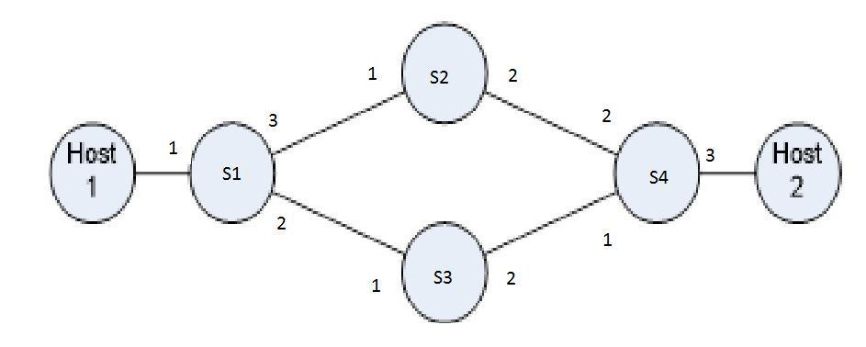

PROGRAM:

sh ovs-ofctl add-flow s1 dl_type=0x800, nw_proto=6, tp_dst=80, in_port=1, actions=output:2 (HTTP Traffic Input port 1 ,Output Port 2)
sh ovs-ofctl add-flow s1 in_port=2,actions=output:1 (Switch 1 Input Port 2 Output Port1

sh ovs-ofctl add-flow s1 in_port=1,actions=output:2 (Switch 1 Input Port 1 Output Port2) sh ovs-ofctl add-flow s1 in_port=3,actions=output:1(Switch 1 Input Port 3 Output Port1)

sh ovs-ofctl add-flow s2 in_port=1,actions=output:2 (Switch 2 Input Port 1 Output Port2) sh ovs-ofctl add-flow s2 in_port=2,actions=output:1(Switch 2 Input Port 2 Output Port1)

sh ovs-ofctl add-flow s3 in_port=1,actions=output:2 (Switch 3 Input Port 1 Output Port2) sh ovs-ofctl add-flow s3 in_port=2,actions=output:1 (Switch 2 Input Port 2 Output Port1)

sh ovs-ofctl add-flow s4 dl_type=0x800, nw_proto=6, tp_dst=80, in_port=2, actions=output:3(HTTP Traffic Input port 2 ,Output Port 3)

sh ovs-ofctl add-flow s4 dl_type=0x800, nw_proto=6, tp_dst=80, in_port=3, actions=output:2(HTTP Traffic Input port 3 ,Output Port 2)

sh ovs-ofctl add-flow s4 dl_type=0x800,nw_proto=6,in_port=1,actions=output:3 (Switch 4 Input Port 1 Output Port3)

sh ovs-ofctl add-flow s4 dl_type=0x800,nw_proto=6,in_port=3,actions=output:1 (Switch 4 Input Port 3 Output Port1)

h2 python -m SimpleHTTPServer 80 & (making host2 as a http server)

The following screenshots shows the empty flow table before adding the rules.
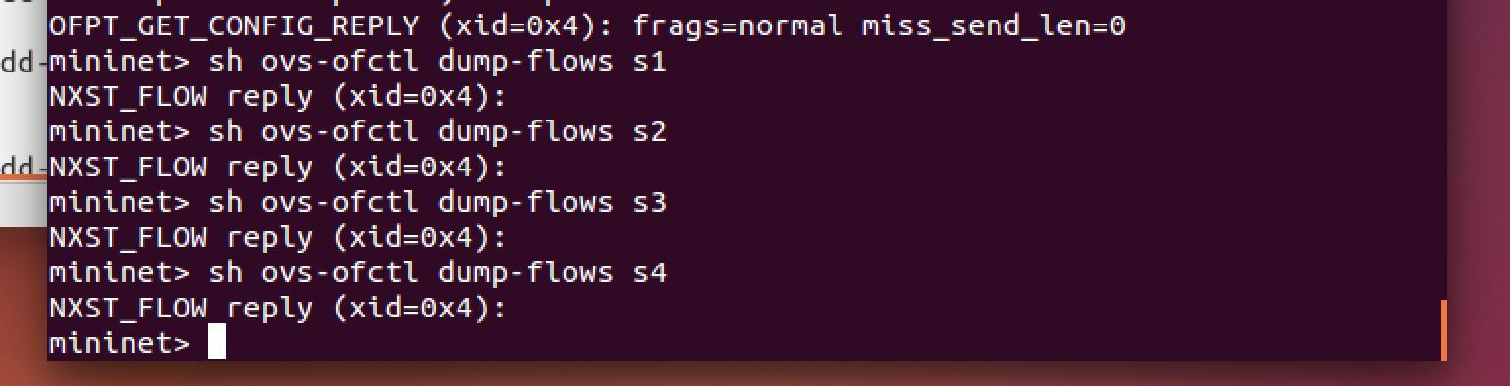

The following screenshot shows the rules being applied on the switches.
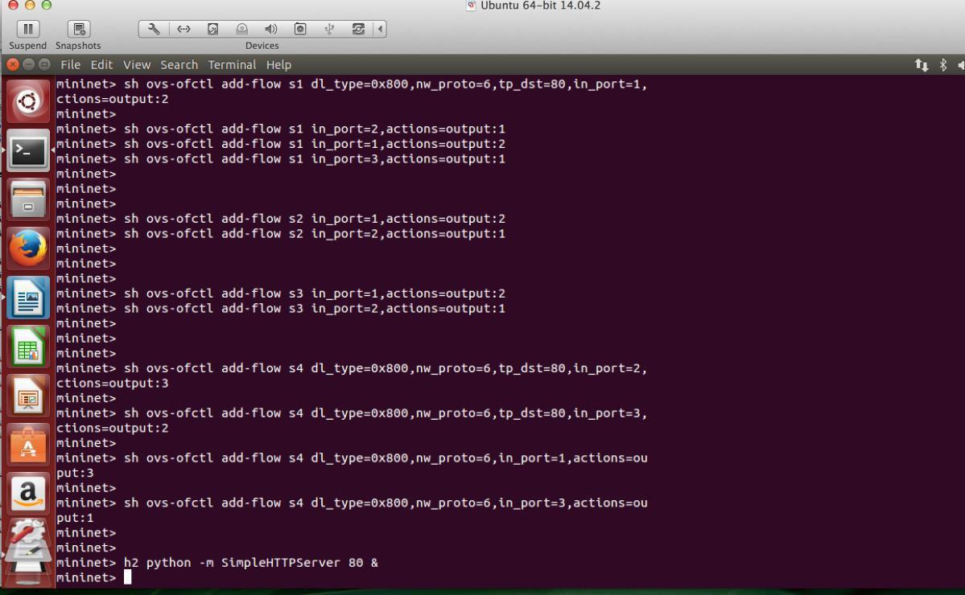
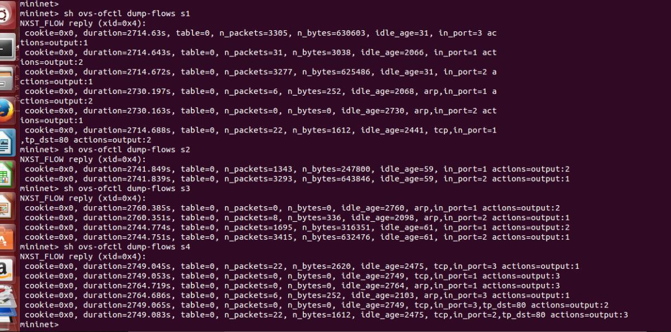
The following screenshots shows the flow table after adding the rules.

